Reviewed on
justwinepoints.com

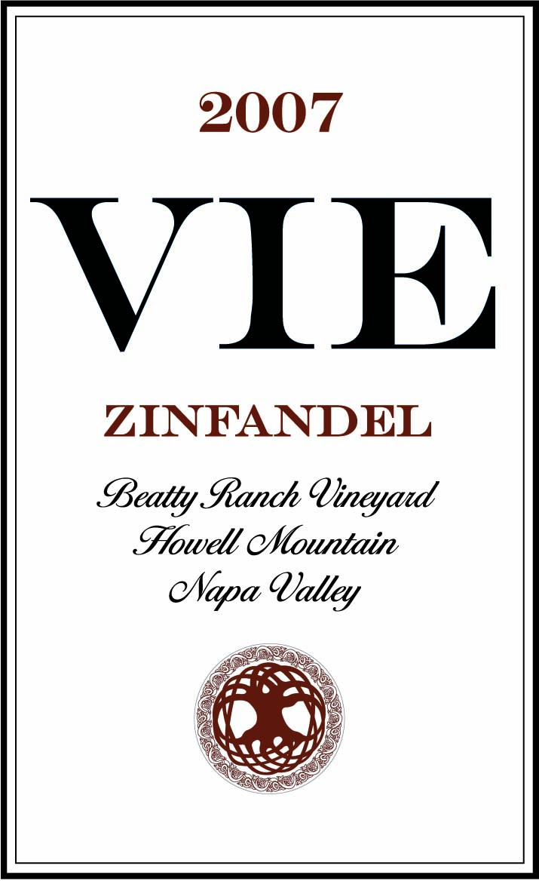

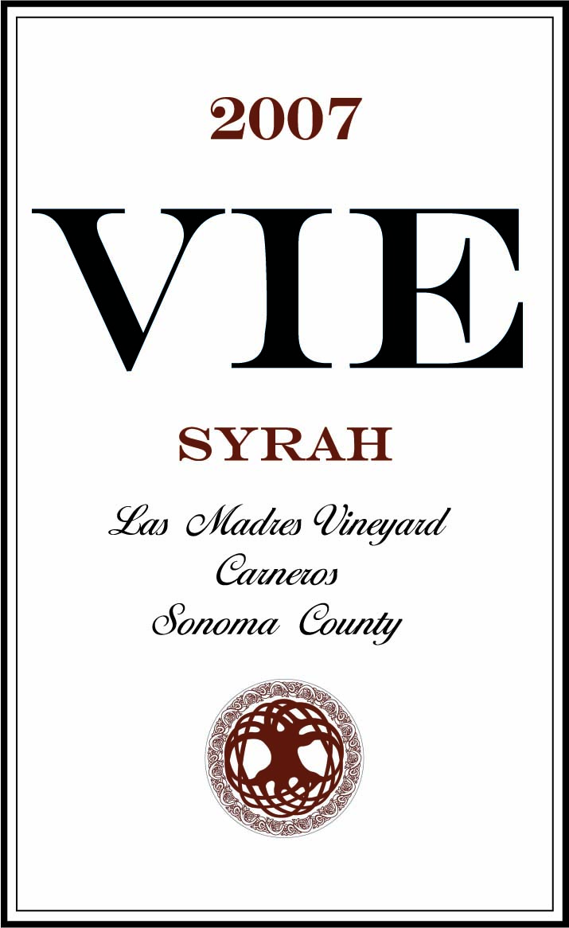

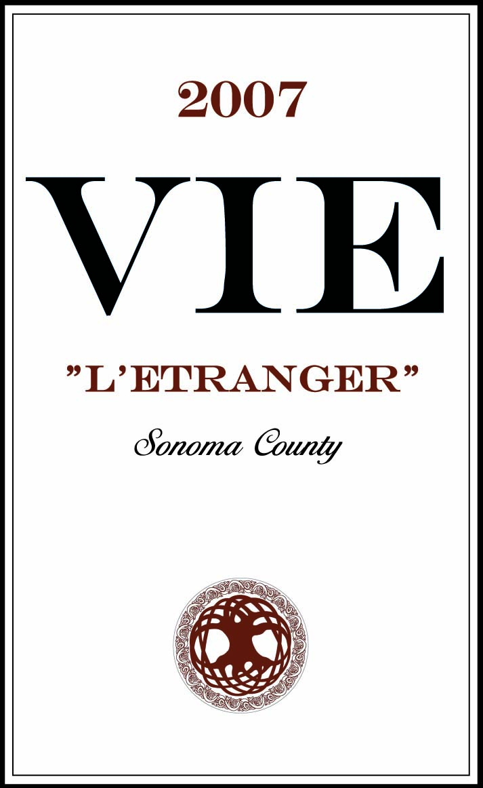

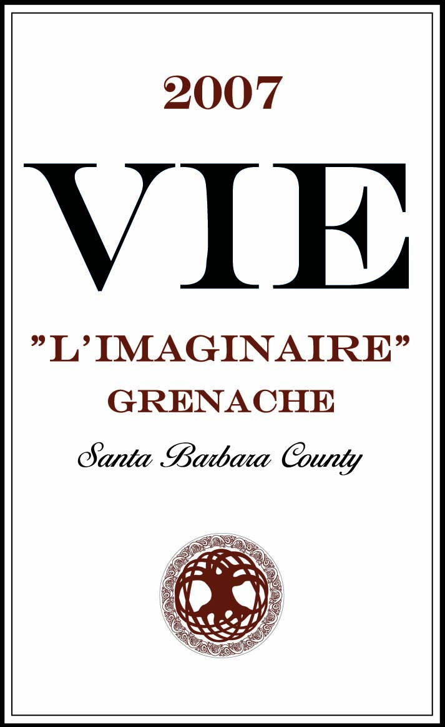

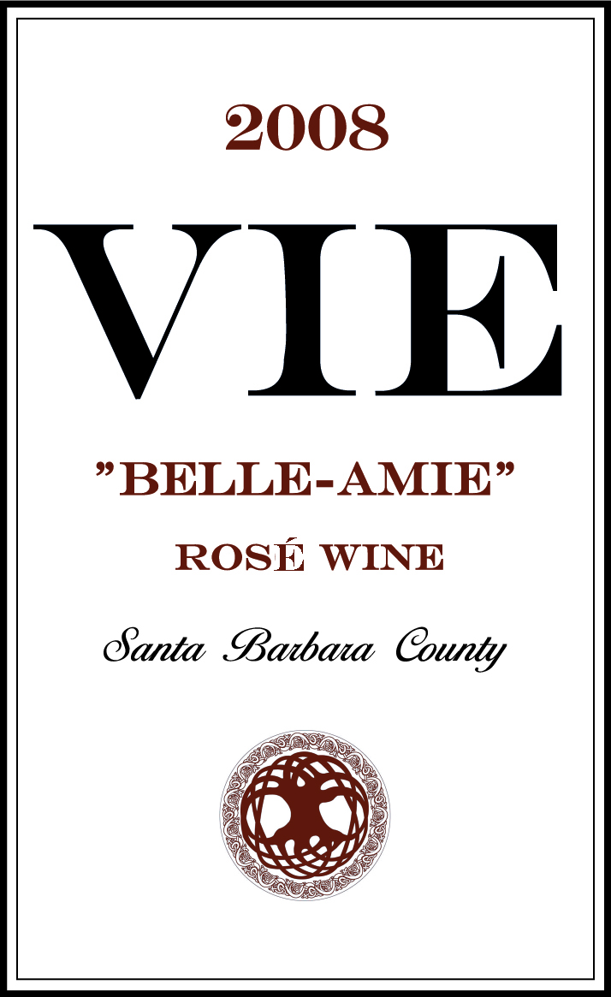
94
Compact raspberry, blackberry, cherry and cola aromas, with pepper spice, chocolate and hints of oak. Full-bodied, bold, spicy fruit in a well-balanced lingering finish. Can use a little age to open up.

98
Doesn’t get much better than this. Wonderful black & blue fruit, spice, with whiffs of smoke and cola. The palate is smooth and sexy, well-balanced and mouth filling, with an explosion of fruit and spice in the never ending finish.

97
Pretty raspberry, blackberry and cherry aromas, with pepper spice, light cola and oak nuances. The much overused “iron fist in a velvet glove” is the only appropriate description of this wine, with the smooth, sexy qualities of syrah fortified with upfront zinfandel fruit and a nice backbone supplied by petite sirah. Yummy!

97
Beautiful bouquet of blackberry, blueberry and strawberry, with dashes of black pepper, floral elements and light traces of minerals. On the palate, this is a wonderful mouthful of fruit and spice, ending in a well-balanced lingering finish.

95
Pretty floral nose, with strawberry, cherry and citrus fruit notes. On the palate, crisp, clean and refreshing, well-balanced fruit with crisp acidity, and a long lingering finish. A great example of an American Rhone-style rose.

